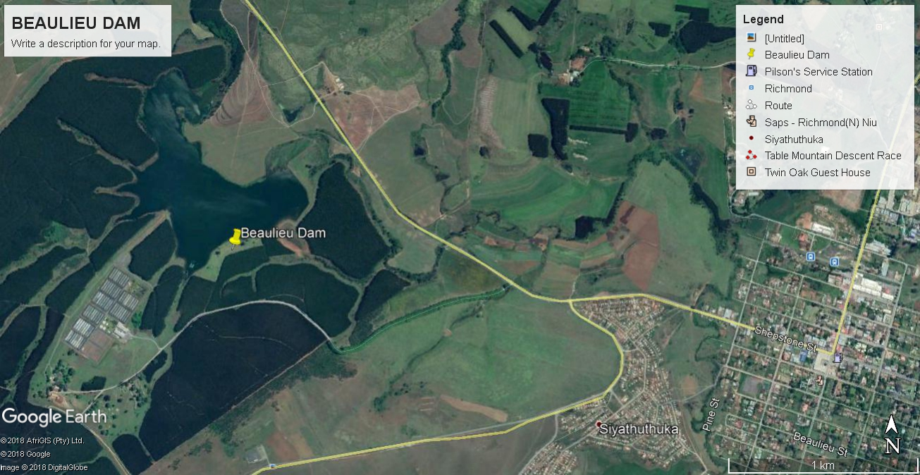
MARATHON PRACTICE EVENT IN RICHMOND

Brand new venue!! 9am Sat 21st April 2018. Beaulieu Dam on the Byrne Valley Road outside Richmond. Hosts are the Beaulieu Dam Recreational Club under the guidance of Midmar Canoe Club.
29°51'57.61"S 30°14'13.18"E
Racing for all age-groups Guppy, K1 or K2 over a 3.6km marathon course with a 200m portage.
Great practice for KZN Marathon Champs on 19th 20th May and SA Champs in June at St Francis Bay.
Laps -
Guppys U8 and U10 - 1 lap
Guppys U12 - 2 laps 1 portage
U14's - 3 laps 2 portages
U16 and U18 - 4 laps and 3 portages
U23 - 5 laps and 4 portages
SNRS - 6 laps and 5 portages
SV - SM - 5 laps and 4 portages
M - SGM - 4 laps and 3 portages
GM - GGM - 3 laps and 2 portages
Catering, toilets, plenty parking and beautiful setting.
Entries at www.canoesa.co.za till 4pm Friday or on the bank. Jnrs R50 Snrs R130

